**Master Functional Document**

|  |  |
| --- | --- |
| **Application** | NGERP - Centra |
| **Service Bundle** | Master Management |
| **Service Request** | Sales Channel |

**Description :**

Region is seperated by sales using Sales Channel master. This master is mapped to program Threshold Mapping master to group the regions into sales region.

**Workflow Process :**

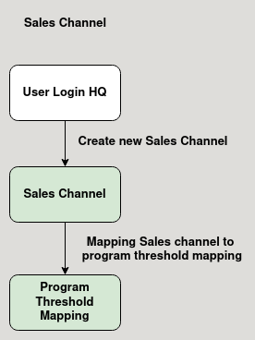

**Business Rules :**

* User should login into HQ to create a Sales Channel.
* This channel is used to categorise regions by sales region.
* After creating the sales channel it is mapped to the program threshold mapping master.